**Setting up Your Excel Environment**

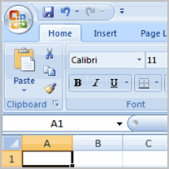Before you begin creating spreadsheets in Excel, you may want to **set up your Excel environment** and become familiar with a few **key tasks and features** such as how to minimize and maximize the Ribbon, configure the Quick Access toolbar, switch page views, and access your Excel options.

### Exploring and Setting Up Your Excel Environment

[Watch the video!](http://www.gcflearnfree.org/content/screencasts/shared/player_776x600.aspx?screenCast=ex07_setup) (5:19 min) - [Tips](http://www.gcflearnfree.org/PopUps/VideoTips.aspx) for watching our videos.

##### Exploring the Excel Environment

The **tabbed Ribbon menu system** is how you navigate through Excel and access the various Excel commands. If you have used previous versions of Excel, the Ribbon system replaces the traditional menus. Above the Ribbon in the upper-left corner is the **Microsoft Office Button**. From here, you can access important options such as New, Save, Save As, and Print. By default the **Quick Access Toolbar** is pinned next to the Microsoft Office Button, and includes commands such as Undo and Redo.  
  
At the bottom, left area of the spreadsheet, you will find worksheet tabs. By default, **three worksheet tabs** appear each time you create a new workbook. On the bottom, right area of the spreadsheet you will find page view commands, the zoom tool, and the horizontal scrolling bar.

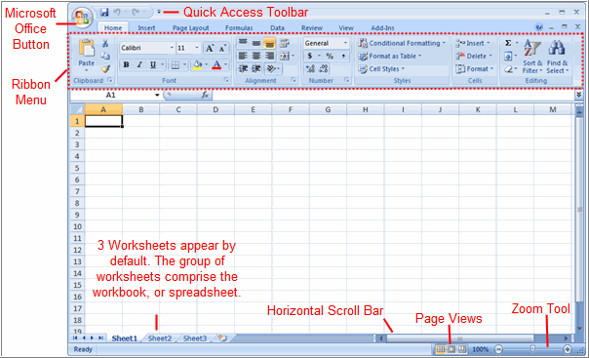

##### To Zoom In and Out:

* Locate the **zoom bar** in the bottom, right corner.
* Left-click the **slider** and **drag** it to the left to zoom in and to the right to zoom out.

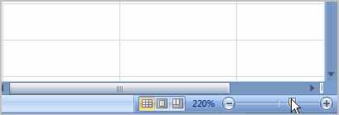

##### To Scroll Horizontally in a Worksheet:

* Locate the **horizontal scroll bar** in the bottom, right corner.
* Left-click the bar and move it from left to right.

##### To Change Page Views

* Locate the **Page View options** in the bottom, right corner. The Page View options are Normal, Page Layout, and Page Break.
* Left-click an option to select it.

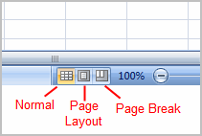

The default is **Normal View**.

##### To Add Commands to the Quick Access Toolbar:

* Click the **arrow** to the right of the Quick Access toolbar.
* Select the **command** you wish to add from the drop-down list. It will appear in the Quick Access toolbar.

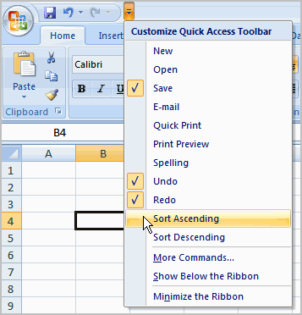

OR

* Select **More Commands** from the menu and a dialog box appears.
* Select the command you wish to add.
* Click the **Add** button.
* Click **OK**.

The Save, Undo, and Redo commands appear by default in the Quick Access toolbar. You may wish to add other commands to make using specific Excel features more convenient for you.

##### To Minimize and Maximize the Ribbon:

* Click the **drop-down arrow** next to the Quick Access toolbar.
* Select **Minimize Ribbon** from the list. The Ribbon disappears.
* To maximize the ribbon, click the arrow again and select **Minimize the Ribbon** to toggle the feature off.

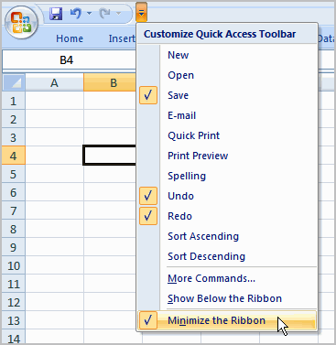

You can also minimize and maximize the Ribbon by right-clicking anywhere in the main menu and selecting **Minimize the Ribbon** in the menu that appears.

The new, **tabbed Ribbon system** replaces traditional menus in Excel 2007. It is designed to be responsive to your current task and easy to use; however, you can choose to **minimize the Ribbon** if you would prefer to use different menus or keyboard shortcuts.

##### The Microsoft Office Button

The **Microsoft Office Button** appears at the top of the Excel window. When you left-click the button, a menu appears. From this menu you can create a new spreadsheet, open existing files, save files in a variety of ways, and print. You can also add security features, send, publish, and close files.

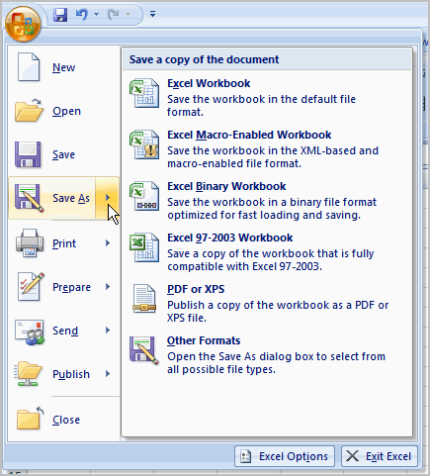

##### To Change the Default Excel Options:

* Click the **Excel Options** button. A dialog box will appear.
* Select a **category** on the left to access different Excel options.

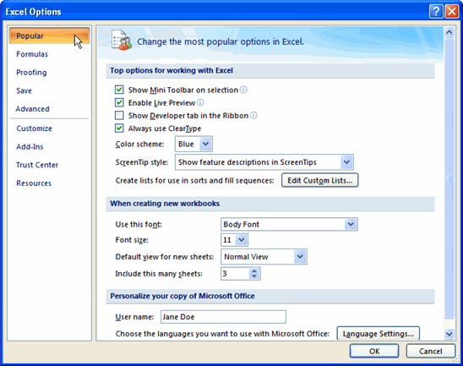

* Modify any of the default settings.
* Click OK.

As you learn more about Excel and become proficient at using it, you may want to modify some of the settings. As a **beginning user**, it is usually best to **leave** the **default settings**.

### Starting a Workbook

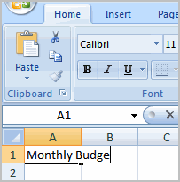You will need to know how to **insert text** and **numbers** into Excel workbooks to be able to use it to calculate, analyze, and organize data. In this lesson, you will learn how to create a new workbook, insert and delete text, navigate a worksheet, and save an Excel workbook.

### Your First Workbook

[Watch the video!](http://www.gcflearnfree.org/content/screencasts/shared/player_776x600.aspx?screenCast=ex07_text) (5:13 min) - [Tips](http://www.gcflearnfree.org/PopUps/VideoTips.aspx) for watching our videos.

##### To Create a New, Blank Workbook:

* Left-click the **Microsoft Office Button**.
* Select **New**. The New Workbook dialog box opens and Blank Workbook is highlighted by default.

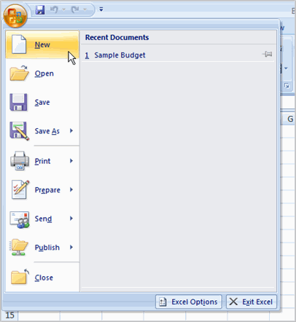

* Click **Create**. A new, blank workbook appears in the window.

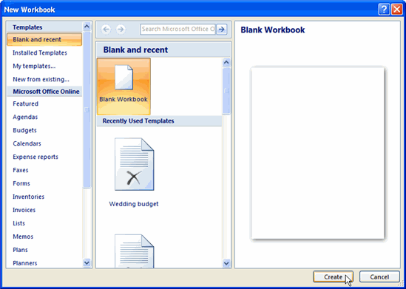

When you first open Excel, the software opens to a new, blank workbook.

##### To Insert Text:

* Left-click a **cell** to select it. Each **rectangle** in the worksheet is called a **cell**. As you select a cell, the **cell address** appears in the **Name Box**.

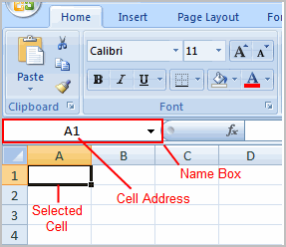

* Enter **text** into the **cell** using your keyboard. The text appears in the cell and in the **formula bar**.

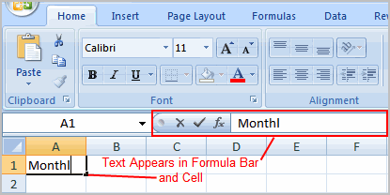

Each cell has a name, or a **cell address** based on the **column** and **row** it is in. For example, this cell is C3 since it is where column C and row 3 intersect.

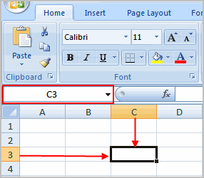

##### To Edit or Delete Text:

* Select the cell.
* Press the **Backspace** key on your keyboard to delete text and make a correction.
* Press the **Delete** key to delete the entire contents of a cell.

You can also make changes to and delete text from the **formula bar**. Just select the cell and place your insertion point in the formula bar.

##### To Move Through a Worksheet Using the Keyboard:

* Press the **Tab** key to move to the **right** of the selected cell.
* Press the **Shift** key and then the **Tab** key to move to the **left** of the selected cell.
* Use the **Page Up** and **Page Down** keys to navigate the worksheet.
* Use the arrow keys.

##### To Save the Workbook:

* Left-click the **Microsoft Office Button**.
* Select **Save** or **Save As**.
  + **Save As** allows you to name the file and choose a location to save the spreadsheet. Choose **Save As** if you'd like to save the file for the **first** time or if you'd like to save the file as a different name.
  + Select **Save** if the file has already been named.

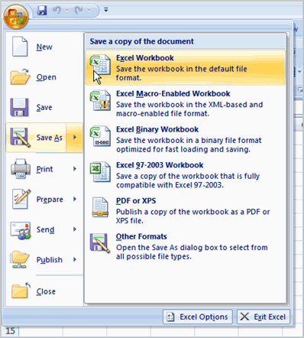

You can save a workbook in many ways, but the two most common are as an **Excel Workbook**, which saves it with a 2007 file extension, and as an **Excel 97-2003 Workbook**, which saves the file in a compatible format so people who have earlier versions of Excel can open the file.

### Modifying Columns, Rows, and Cells

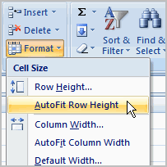When you open a new, blank workbook, the cells, columns, and rows are set to a **default size**. You do have the ability to change the size of each, and to insert new columns, rows, and cells, as needed. In this lesson, you will learn various methods to modify the column width and row height, in addition to how to insert new columns, rows, and cells.

### Columns, Rows, and Cells

[Watch the video!](http://www.gcflearnfree.org/content/screencasts/shared/player_776x600.aspx?screenCast=ex07_column) (6:19 min) - [Tips](http://www.gcflearnfree.org/PopUps/VideoTips.aspx) for watching our videos.

Download the [example](http://www.gcflearnfree.org/content/downloads/ex07_Budget_lesson3.xlsx) to work along with the video.

##### To Modify Column Width:

* Position the **cursor** over the **column line** in the column heading and a **double arrow** will appear.

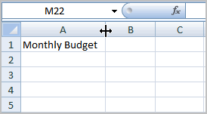

* Left-click the mouse and **drag** the cursor to the **right** to **increase** the column width or to the **left** to **decrease** the column width.
* **Release** the mouse button.

OR

* Left-click the **column heading** of a column you'd like to modify. The entire column will appear **highlighted**.

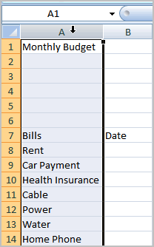

* Click the **Format** command in the Cells group on the **Home** tab. A menu will appear.

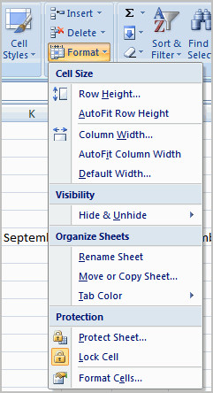

* Select **Column Width** to enter a **specific** column **measurement**.
* Select **AutoFit Column Width** to adjust the column so all the text will fit.

##### To Modify the Row Height:

* Position the **cursor** over the **row line** you want to modify and a **double arrow** will appear.

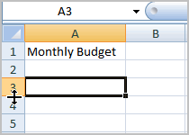

* Left-click the mouse and **drag** the cursor **upward** to **decrease** the row height or **downward** to **increase** the row height.
* **Release** the mouse button.

OR

* Click the **Format** command in the Cells group on the **Home** tab. A menu will appear.



* Select **Row Height** to enter a **specific** row **measurement**.
* Select **AutoFit Row Height** to adjust the row so all the text will fit.

##### To Insert Rows:

* Select the row **below** where you want the new row to appear.
* Click the **Insert** command in the Cells group on the Home tab. The row will appear.

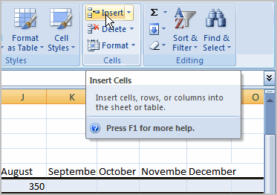

The new row always appears above the selected row.

Make sure that you select the **entire row** below where you want the new row to appear and **not** just the **cell**. If you select just the cell and then click Insert, only a new cell will appear.

##### To Insert Columns:

* Select the column to the right of where you want the column to appear.
* Click the **Insert** command in the Cells group on the Home tab. The column will appear.

The new column always appears to the left of the selected column. For example, if you want to insert a column between September and October, select the October column and click the Insert command.

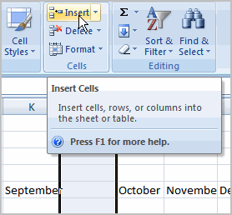

Make sure that you select the **entire column** to the right of where you want the new column to appear and **not** just the **cell**. If you select just the cell and then click Insert, only a new cell will appear.

##### To Delete Rows and Columns:

* Select the row or column you’d like to delete.
* Click the Delete command in the Cells group on the Home tab.

### Formatting Text

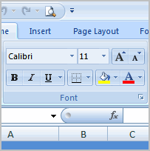Once you have entered information into a spreadsheet, you will need to be able to **format** it. In this lesson, you will learn how to use the bold, italic, and underline commands; modify the font style, size, and color; and apply borders and fill colors.

### Formatting Cells

[Watch the video!](http://www.gcflearnfree.org/content/screencasts/shared/player_776x600.aspx?screenCast=ex07_format_text) (8:32 min) - [Tips](http://www.gcflearnfree.org/PopUps/VideoTips.aspx) for watching our videos.

Download the [example](http://www.gcflearnfree.org/content/downloads/ex07_Budget_lesson4.xlsx) to work along with the video.

##### To Format Text in Bold or Italics:

* Left-click a **cell** to select it or drag your cursor over the text in the formula bar to select it.
* Click the **Bold** or **Italics** command.

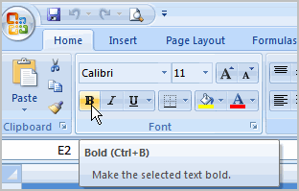

You can select entire columns and rows, or specific cells. To select the **entire column**, just left-click the column heading and the entire column will appear as selected. To select **specific cells**, just left-click a cell and drag your mouse to select the other cells. Then, release the mouse button.

##### To Format Text as Underlined:

* Select the cell or cells you want to format.
* Click the drop-down arrow next to the Underline command.
* Select the **Single Underline** or **Double Underline** option.

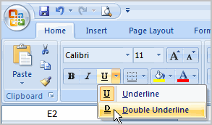

##### To Change the Font Style

* Select the cell or cells you want to format.
* Left-click the **drop-down arrow** next to the **Font Style** box on the Home tab.
* Select a **font style** from the list.

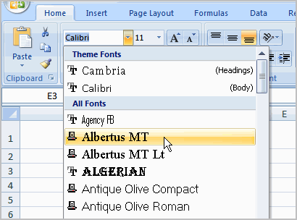

As you move over the font list, the Live Preview feature previews the font for you in the spreadsheet.

##### To Change the Font Size:

* Select the cell or cells you want to format.
* Left-click the **drop-down arrow** next to the **Font Size** box on the Home tab.
* Select a **font size** from the list.

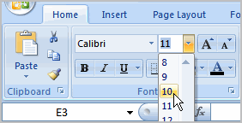

##### To Change the Text Color:

* Select the cell or cells you want to format.
* Left-click the **drop-down arrow** next to the **Text Color** command. A color palette will appear.
* Select a color from the palette.

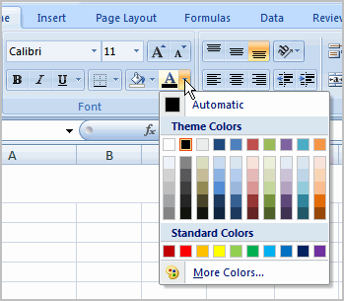

OR

* Select **More Colors**. A dialog box will appear.
* Select a color.
* Click **OK**.

##### To Add a Border:

* Select the cell or cells you want to format.
* Click the **drop-down arrow** next to the **Borders** command on the Home tab. A menu will appear with border options.

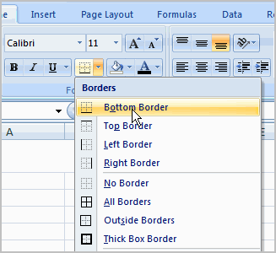

* Left-click an option from the list to select it.

You can change the **line style** and **color** of the border.

##### To add a Fill Color:

* Select the cell or cells you want to format.
* Click the **Fill command**. A color palette will appear.
* Select a color.

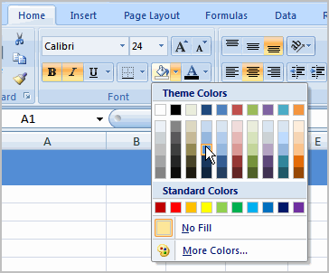

OR

* Select **More Colors**. A dialog box will appear.
* Select a color.
* Click **OK**.

You can use the **fill color feature** to format columns and rows, and format a worksheet so that it is easier to read.

##### To Format Numbers and Dates:

* Select the cell or cells you want to format.
* Left-click the **drop-down arrow** next to the **Number Format** box.
* Select one of the options for formatting numbers.

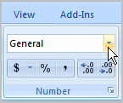

By default, the numbers appear in the **General** category, which means there is no special formatting.

In the Number group, you have some other options. For example, you can change the U.S. dollar sign to another currency format, numbers to percents, add commas, and change the decimal location.

### Creating Simple Formulas

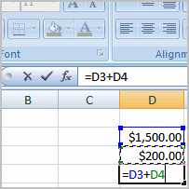Excel can be used to **calculate** and **analyze** numerical information; however, you will need to know how to write **formulas** to take maximize Excel's capabilities. A formula is an equation that performs a calculation using values in the worksheet. In this lesson you will learn how to **create simple formulas** using mathematical operators such as the addition, subtraction, multiplication, and division signs.

### Simple Formulas

[Watch the video!](http://www.gcflearnfree.org/content/screencasts/shared/player_776x600.aspx?screenCast=ex07_formulas) (10:47 min) - [Tips](http://www.gcflearnfree.org/PopUps/VideoTips.aspx) for watching our videos.

Download the [example](http://www.gcflearnfree.org/content/downloads/ex07_Budget_lesson5.xlsx) to work along with the video.

##### To Create a Simple Formula that Adds Two Numbers:

* Click the cell where the formula will be defined (C5, for example).
* Type the equal sign (=) to let Excel know a formula is being defined.
* Type the first number to be added (e.g., 1500)
* Type the **addition sign (+)** to let Excel know that an add operation is to be performed.
* Type the second number to be added (e.g., 200)
* Press **Enter** or click the **Enter button** on the Formula bar to complete the formula.

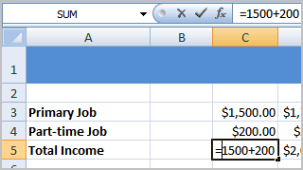

##### To Create a Simple Formula that Adds the Contents of Two Cells:

* Click the cell where the answer will appear (C5, for example).
* Type the equal sign (=) to let Excel know a formula is being defined.
* Type the cell number that contains the first number to be added (C3, for example).
* Type the **addition sign (+)** to let Excel know that an add operation is to be performed.
* Type the cell address that contains the second number to be added (C4, for example).
* Press **Enter** or click the **Enter button** on the Formula bar to complete the formula.

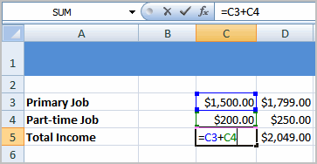

##### To Create a Simple Formula using the Point and Click Method:

* Click the cell where the answer will appear (C30, for example).
* Type the equal sign (=) to let Excel know a formula is being defined.
* Click on the **first cell** to be included in the formula (C5, for example).
* Type the **subtraction sign (-)** to let Excel know that a subtraction operation is to be performed.
* Click on the **next cell** in the formula (C29, for example).

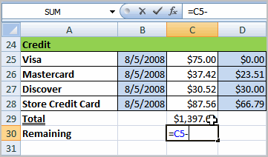

* Press **Enter** or click the **Enter button** on the Formula bar to complete the formula.

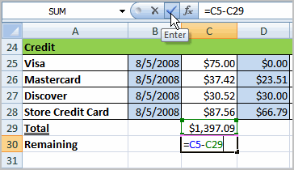

##### To Create a Simple Formula that Multiplies the Contents of Two Cells:

* Select the cell where the answer will appear (E32, for example).
* Type the equal sign (=) to let Excel know a formula is being defined.
* Click on the **first cell** to be included in the formula (C9, for example) or type a number.
* Type the multiplication symbol (*) by pressing the Shift key and then the number 8 key. The operator displays in the cell and Formula bar.
* Click on the **next cell** in the formula or type a number (12, for example).
* Press **Enter** or click the **Enter button** on the Formula bar to complete the formula.

.

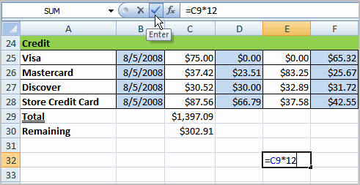

##### To Create a Simple Formula that Divides One Cell by Another:

* Click the cell where the answer will appear.
* Type the equal sign (=) to let Excel know a formula is being defined.
* Click on the **first cell** to be included in the formula.
* Type a division symbol. The operator displays in the cell and Formula bar.
* Click on the **next cell** in the formula.
* **Enter** or click the **Enter button** on the Formula bar to complete the formula.

**Using Cell References**

As you can see, there are many ways to create a simple formula in Excel. Most likely you will choose one of the methods that enters the cell address into the formula, rather than an actual number. The cell address is basically the name of the cell and can be found in the Name Box.



The following example uses actual numbers in the formula in C5.



When a cell address is used as part of a formula, this is called a **cell reference**. It is called a **cell reference** because instead of entering specific numbers into a formula, the cell address refers to a specific cell. The following example uses cell references in the formula in C30.



### Working with Cells

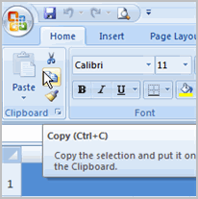It is important to know how to **move information** from one cell to another in Excel. Learning the various ways will **save you time** and make working with Excel easier. Certain methods are more appropriate depending on how much information you need to move and where it will reside on the spreadsheet. In this lesson you will learn how to **cut**, **copy**, and **paste**, as well as **drag** and **drop** information.

##### Working with Cells

[Watch the video!](http://www.gcflearnfree.org/content/screencasts/shared/player_776x600.aspx?screenCast=ex07_cells) (6:10 min) - [Tips](http://www.gcflearnfree.org/PopUps/VideoTips.aspx) for watching our videos.

Download the [example](http://www.gcflearnfree.org/content/downloads/ex07_Budget_lesson6.xlsx) to work along with the video.

##### To Copy and Paste Cell Contents:

* Select the **cell or cells** you wish to **copy**.
* Click the **Copy** command in the Clipboard group on the Home tab. The border of the selected cells will change appearance.

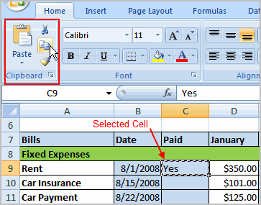

* Select the **cell or cells** where you want to **paste** the information.
* Click the **Paste** command. The copied information will now appear in the new cells.

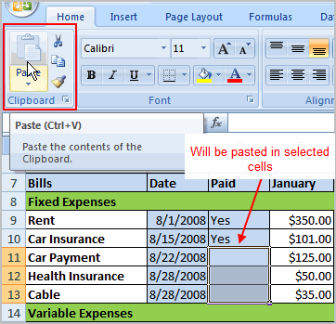

To select **more than one adjoining cell**, left-click one of the cells, drag the cursor until all the cells are selected, and release the mouse button.

The copied cell will **stay selected** until you perform your next task, or you can double-click the cell to **deselect** it.

##### To Cut and Paste Cell Contents:

* Select the **cell or cells** you wish to **copy**.
* Click the **Cut** command in the Clipboard group on the Home tab. The border of the selected cells will change appearance.

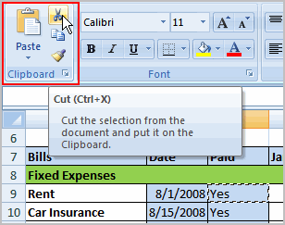

* Select the **cell or cells** where you want to **paste** the information.
* Click the **Paste** command. The cut information will be removed from the **original cells** and **now appear** in the new **cells**.

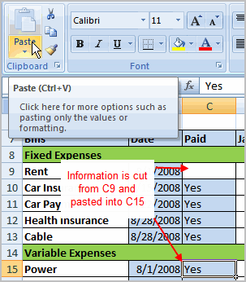

The keyboard shortcut for Paste is the **Control Key** and the **V** key.

##### To Drag and Drop Information:

* Select the **cell or cells** you wish to move.
* Position your **mouse pointer** near one of the **outside edges** of the selected cells. The mouse pointer changes from a **large, white cross** to a **black cross with 4 arrows**.

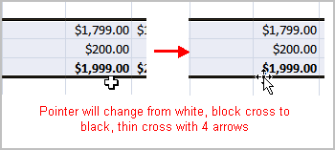

* Left-click and **hold** the mouse button and **drag** the cells to the new location.

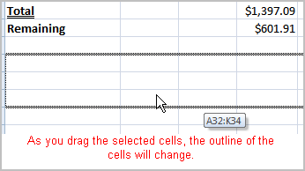

* Release the mouse button and the information appears in the new location.

##### To Use the Fill Handle to Fill Cells:

* Position your cursor over the **fill handle** until the large white cross becomes a thin, black cross.

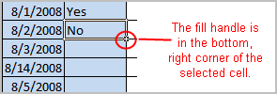

* Left-click your mouse and **drag it** until all the cells you want to fill are highlighted.

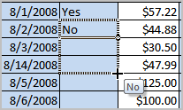

* Release the mouse button and all the selected cells are filled with the information from the original cell.

The fill handle doesn't **always** copy information from one cell directly into another cell. Depending on the data entered in the cell, it may fill the data in other ways. For example, if I have the formula =A1+B1 in cell C1, and I use the fill handle to fill the formula into cell C2, the formula doesn't appear the same in C2 as it does in C1. Instead of =A1+B1, you will see =A2+B2.

You can use the fill handle to fill cells horizontally or vertically.

### Printing Workbooks

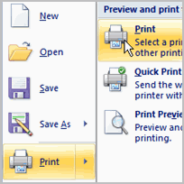In Excel, there are many things you can do to prepare your workbook for printing. Many of these tasks make it easier to **format the spreadsheet** for the printed page.   
  
In this lesson you will learn how to view the spreadsheet in print preview, modify margins, change the page orientation, use the scale to fit feature, use the Print Tiles command, insert breaks, and more.

### Preparing to Print and Printing

[Watch the video!](http://www.gcflearnfree.org/content/screencasts/shared/player_776x600.aspx?screenCast=ex07_printing) (10:14 min) - [Tips](http://www.gcflearnfree.org/PopUps/VideoTips.aspx) for watching our videos.

Download the [example](http://www.gcflearnfree.org/content/downloads/ex07_Budget_lesson7.xlsx) to work along with the video.

##### To View the Spreadsheet in Print Preview:

* Left-click the **Microsoft Office Button**.
* Select **Print**.
* Select **Print Preview**. The spreadsheet will appear in Print Preview view.

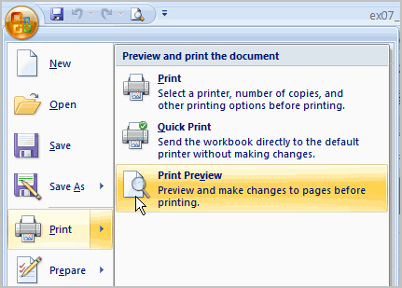

Click the **Close Print Preview** button Close Print Previewto return to the Normal View.

To make previewing your spreadsheet easier, add the **Print Preview** command to the Quick Access toolbar.

##### Exploring Print Preview:

Once you are in Print Preview, you can access many of the same features that you can from the Ribbon; however, in Print Preview you can see how the spreadsheet will appear in printed format.

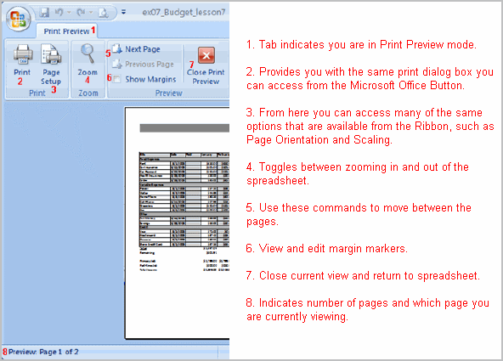

##### To Modify Margins, Column Width, or Row Height While in Print Preview:

* Click the **Print Preview** command on the Quick Access toolbar, or select Print Preview from the Microsoft Office Button menu. The spreadsheet opens in print preview mode.
* Hover your cursor over one of the **black margin markers** until a **double arrow** appears.

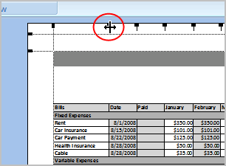

* Left-click and drag the marker to the desired location. The change will be reflected in the spreadsheet.

##### To Modify Margins:

* Select the **Page Layout** tab.
* Left-click the **Margins** command.
* Choose one of the predefined settings or enter custom margins.

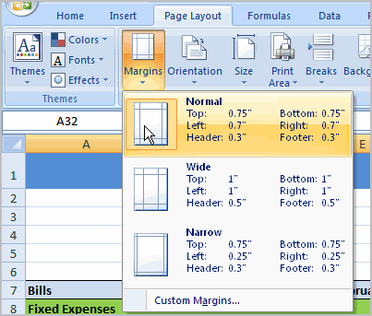

##### To Change Page Orientation:

* Select the **Page Layout** tab.
* Left-click the **Orientation** command.
* Select either Portrait or Landscape.

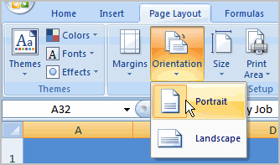

**Portrait** orients the page **vertically**, while **Landscape** orients the page **horizontally**.

##### To Use Scale to Fit:

* Select the **Page Layout** tab.
* Locate the Scale to Fit group.
* Enter a specific **height** and **width**, or use the percentage field to decrease the spreadsheet by a specific percent.

Scale to Fit is a useful feature that can help you format spreadsheets to fit on a page. Be careful with how small you scale the information -- it can become difficult to read!

##### To Change the Paper Size:

* Select the **Page Layout** tab.
* Click the **Size** command.
* Select a size option from the list.

##### To Define a Print Area:

* Left-click and drag your mouse to **select the cells** you wish to print.
* Click the **Print Area** command.
* Choose **Set Print Area**.

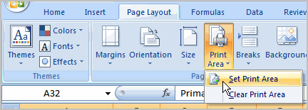

Now, only the selected cells will print. You can confirm this by viewing the spreadsheet in Print Preview.

To return to the default setting, which is the entire worksheet, click the Print Area command and select Clear Print Area.

##### To Insert a Break:

* Select a cell **below** where you want the break to appear.
* Select the **Breaks** command.
* Select **Insert Break**.

Click Print Preview to confirm the break appears in the correct place in your spreadsheet.

##### To Use the Print Titles command:

This is an important command to be familiar with if you intend to print your worksheets. It allows you to select **specific rows** and/or **columns** to appear on **each** printed sheet. Imagine how difficult it would be to read page 48 of a printed spreadsheet if the column and row headings only appeared on the first page.

* Select the **Page Layout** tab.
* Click the **Print Titles** command. The Page Setup dialog box appears.
* Click the icon at the end of the field.

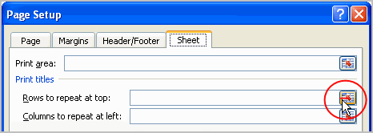

* Select the first row in the spreadsheet that you want to appear on **each printed page**.

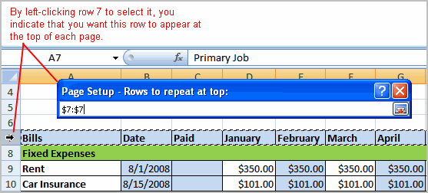

* Repeat for the column, if necessary.
* Click OK.

##### To Print from the Microsoft Office Button:

* Left-click the **Microsoft Office Button**.
* Select **Print actionPrint**. The Print dialog box appears.

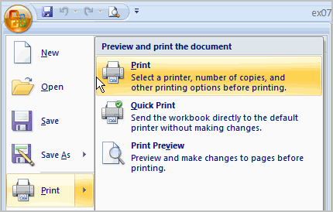

* Select a printer if you wish to use a printer other than the default setting.
* Click **Properties** to change any necessary settings.
* Choose whether you want to print specific pages, all of the worksheet, a selected area, the active sheet, or the entire workbook.
* Select the number of copies you'd like to print.
* Click **OK**.

You can select **Quick Print** to bypass the Print dialog box.

### Creating Complex Formulas

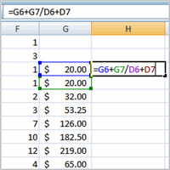Excel is a spreadsheet application and is intended to be used to **calculate** and **analyze numerical information** such as household budgets, company finances, inventory, and more. To do this, you need to understand **formulas**.  
  
In this lesson, we’ll discuss **complex formulas** that use multiple mathematical operators, and that use **absolute** and **relative references**.

### Complex Formulas

[Watch the video!](http://www.gcflearnfree.org/content/screencasts/shared/player_776x600.aspx?screenCast=ex07_formulas_complex) (12:26 min) - [Tips](http://www.gcflearnfree.org/PopUps/VideoTips.aspx) for watching our videos.

Download the [example](http://www.gcflearnfree.org/content/downloads/ex07_Inventory_lesson8.xlsx) to work along with the video.

##### Complex Formulas Defined

Simple formulas have **one** mathematical operation. **Complex formulas** involve **more than one** mathematical operation.

**Simple Formula:** =2+2   
**Complex Formula:** =2+2*8

To calculate complex formulas correctly, you must perform certain operations before others. This is defined in the **order of operations**.

##### The Order of Operations

The order of mathematical operations is very important. If you enter a formula that contains several operations, Excel knows to work those operations in a specific order. The **order of operations** is:

1. Operations enclosed in parenthesis
2. Exponential calculations (to the power of)
3. Multiplication and division, whichever comes first
4. Addition and subtraction, whichever comes first

A mnemonic that can help you remember this is **P**lease **E**xcuse **M**y **D**ear **A**unt **S**ally (P.E.M.D.A.S).

**Example 1**

Using this order, let us see how the formula **20/(8-4)*8-2** is calculated in the following breakdown:

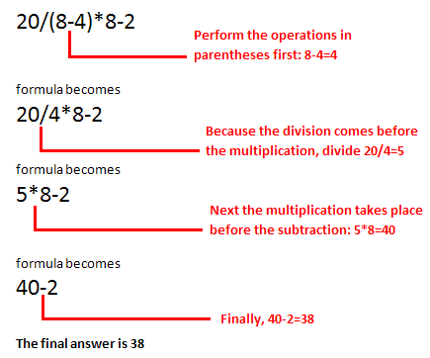

**Example 2**

**3+3*2=?**

Is the answer 12 or 9? Well, if you calculated in the order in which the numbers appear, 3+3*2, you'd get the wrong answer, 12. You must follow the order of operations to get the correct answer.

##### To Calculate the Correct Answer:

1. Calculate 3*2 first because **multiplication** comes **before addition** in the order of operations. The answer is 6.
2. Add the answer obtained in step #1, which is 6, to the number 3 that opened the equation. In other words, add 3 + 6.
3. The answer is 9.

**Complex Formulas (continued)**

Before moving on, let's explore some more formulas to make sure you understand the order of operations by which Excel calculates the answer.

|  |  |
| --- | --- |
| **4*2/4** | **Multiply** 4*2 **before** performing the **division** operation because the multiplication sign comes before the division sign. The answer is 2. |
| **4/2*4** | **Divide** 4 by 2 **before** performing the **multiplication** operation because the division sign comes before the multiplication sign. The answer is 8. |
| **4/(2*4)** | Perform the operation in **parentheses** (2*4) first and **divide** 4 by this result. The answer is 0.5. |
| **4-2*4** | **Multiply** 2*4 before performing the **subtraction** operation because the multiplication sign is of a higher order than the subtraction sign. The answer is -4. |

### Creating Complex Formulas

Excel **automatically** follows a **standard order of operations** in a complex formula. If you want a certain portion of the formula to be calculated first, put it in parentheses.

##### Example of How to Write a Complex Formula:

* Click the cell where you want the formula **result** to appear. In this example, H6.
* Type the equal sign (=) to let Excel know a formula is being defined.
* Type an open parenthesis, or (
* Click on the **first cell** to be included in the formula (G6, for example).
* Type the **addition sign (+)** to let Excel know that an add operation is to be performed.
* Click on the **second cell** in the formula (G7, for example)
* Type a close parentheses ).

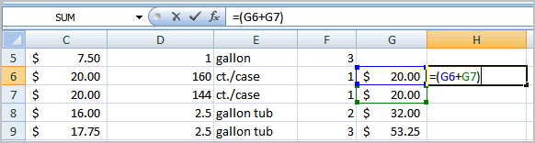

* Type the next mathematical operator, or the **division symbol (/)** to let Excel know that a division operation is to be performed.
* Type an open parenthesis, or (
* Click on the **third cell** to be included in the formula (D6, for example).
* Type the **addition sign (+)** to let Excel know that an add operation is to be performed.
* Click on the **fourth cell** to be included in formula. (D7, for example).
* Type a close parentheses ).

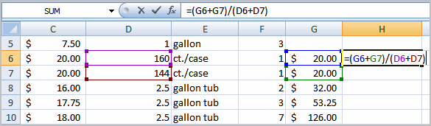

* **Very Important:** Press **Enter** or click the **Enter button** on the Formula bar. This step ends the formula.

To show fewer decimal places, you can just click the **Decrease Decimal** place command on the Home tab.

### What is an Absolute Reference?

In earlier lessons we saw how **cell references** in formulas **automatically adjust** to new locations when the formula is pasted into different cells. This is called a **relative reference**.

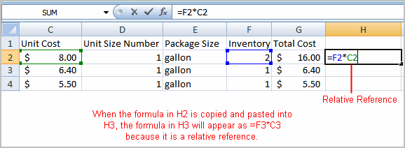

Sometimes, when you copy and paste a formula, you don't want one or more cell references to change. **Absolute reference** solves this problem. **Absolute cell references** in a formula **always** refer to the **same cell** or cell range in a formula. If a formula is copied to a different location, the absolute reference remains the same.

An absolute reference is designated in the formula by the addition of a **dollar sign ($)**. It can precede the column reference or the row reference, or both. Examples of absolute referencing include:

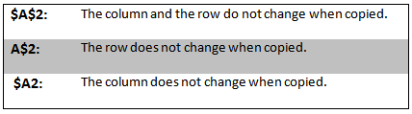

##### To Create an Absolute Reference:

* Select the cell where you wish to write the formula (in this example, H2)
* Type the equal sign (=) to let Excel know a formula is being defined.
* Click on the **first cell** to be included in the formula (F2, for example).
* Enter a mathematical operator (use the multiplication symbol for this example).
* Click on the **second cell** in the formula (C2, for example).
* Add a $ sign before the C and a $ sign before the 2 to create an absolute reference.

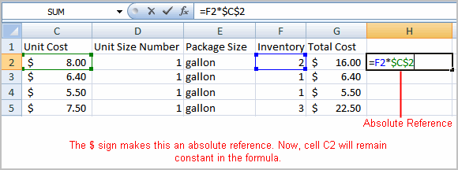

* Copy the formula into H3. The new formula should read =F3*$C$2. The F2 reference changed to F3 since it is a relative reference, but C2 remained constant since you created an absolute reference by inserting the dollar signs.

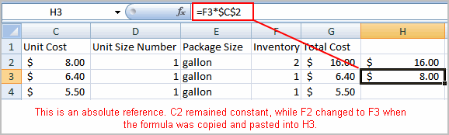

### Working with Basic Functions

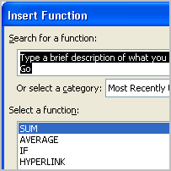A **function is a predefined formula** that performs calculations using specific values in a particular order. While you may think of formulas as being short mathematical equations, like 2 + 2 or F2 * C2, they can actually be very lengthy and involve complex mathematical calculations.   
  
One of the key benefits of functions is that they can save you time since you do not have to write the formula yourself. For example, you could use an Excel function called **Average** to quickly find the average of a range of numbers or the **Sum** function to find the sum of a cell range.  
  
In this lesson, you will learn how to use basic functions such as SUM and AVG, use functions with more than one argument, and how to access the other Excel 2007 functions.

### Basic Functions

[Watch the video!](http://www.gcflearnfree.org/content/screencasts/shared/player_776x600.aspx?screenCast=ex07_basic_functions) (11:34 min) - [Tips](http://www.gcflearnfree.org/PopUps/VideoTips.aspx) for watching our videos.

Download the [example](http://www.gcflearnfree.org/content/downloads/ex07_Inventory_lesson9.xlsx) to work along with the video.

##### The Parts of a Function:

Each function has a specific order, called **syntax**, which must be strictly followed for the function to work correctly.

Syntax Order:

1. All functions begin with the = sign.
2. After the = sign define the **function name** (e.g., Sum).
3. Then there will be an **argument**. An argument is the cell range or cell references that are enclosed by parentheses. If there is more than one argument, separate each by a comma.

An example of a function with one argument that adds a range of cells, A3 through A9:

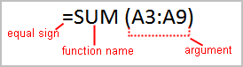

An example of a function with **more than one argument** that calculates the sum of two cell ranges:

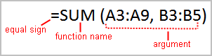

Excel literally has hundreds of different **functions** to assist with your calculations. Building formulas can be difficult and time-consuming. Excel's functions can save you a lot of time and headaches.

### Excel's Different Functions

There are many different functions in Excel 2007. Some of the more common functions include:

##### Statistical Functions:

* **SUM** - summation adds a range of cells together.
* **AVERAGE** - average calculates the average of a range of cells.
* **COUNT** - counts the number of chosen data in a range of cells.
* **MAX** - identifies the largest number in a range of cells.
* **MIN** - identifies the smallest number in a range of cells.

##### Financial Functions:

* **Interest Rates**
* **Loan Payments**
* **Depreciation Amounts**

##### Date and Time functions:

* **DATE** - Converts a serial number to a day of the month
* **Day of Week**
* **DAYS360** - Calculates the number of days between two dates based on a 360-day year
* **TIME** - Returns the serial number of a particular time
* **HOUR** - Converts a serial number to an hour
* **MINUTE** - Converts a serial number to a minute
* **TODAY** - Returns the serial number of today's date
* **MONTH** - Converts a serial number to a month
* **YEAR** - Converts a serial number to a year

You don't have to memorize the functions but should have an idea of what each can do for you.

##### To Calculate the Sum of a Range of Data Using AutoSum:

* Select the **Formulas** tab.
* Locate the **Function Library** group. From here, you can access all the available functions.
* Select the cell where you want the function to appear. In this example, select G42.
* Select the drop-down arrow next to the **AutoSum** command.
* Select **Sum**. A formula will appear in the selected cell, G42.
  + This formula, **=SUM(G2:G41)**, is called a **function**. AutoSum command automatically selects the range of cells from G2 to G41, based on where you inserted the function. You can alter the cell range, if necessary.

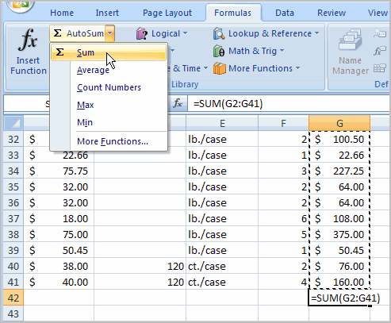

* Press the **Enter key** or **Enter button** on the formula bar. The total will appear.

##### To Edit a Function:

* Select the cell where the **function is defined**.
* Insert the cursor in the formula bar.
* **Edit the range** by deleting and changing necessary cell numbers.

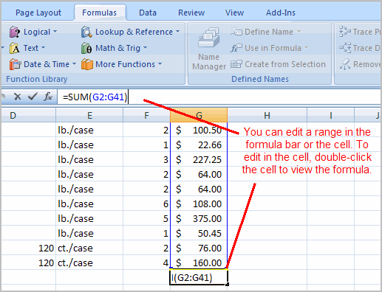

* Click the **Enter** icon.

##### To Calculate the Sum of Two Arguments:

* Select the **cell** where you want the **function to appear**. In this example, G44.
* Click the **Insert Function** command on the Formulas tab. A dialog box appears.
* SUM is selected by default.

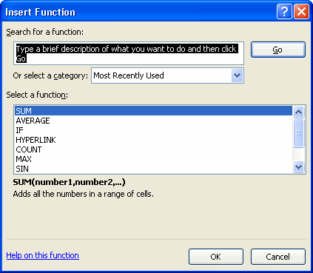

* Click **OK** and the **Function Arguments** dialog box appears so that you can enter the range of cells for the function.
* Insert the cursor in the **Number 1** field.
* In the spreadsheet, select the **first range of cells**. In this example, G21 through G26. The argument appears in the Number 1 field.
  + To select the cells, **left-click cell G21** and **drag the cursor** to G26, and then release the mouse button.
* Insert the cursor in the **Number 2** field.

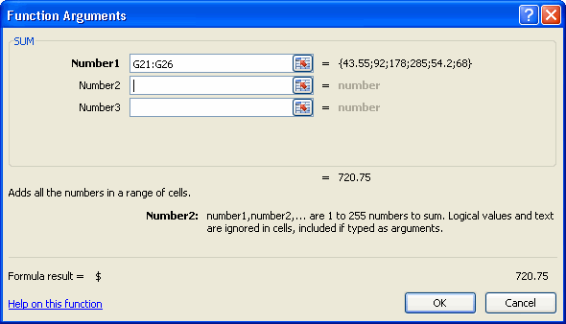

* In the spreadsheet, select the **second range of cells**. In this example, G40 through G41. The argument appears in the Number 2 field.
* Notice that both arguments appear in the function in cell G44 and the formula bar when G44 is selected.

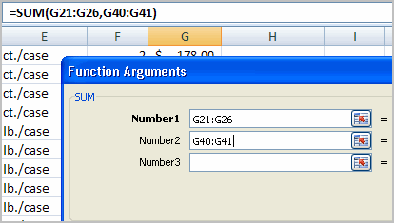

* Click **OK** in the dialog box and the **sum of the two ranges** is calculated.

##### To Calculate the Average of a Range of Data:

* Select the cell where you want the function to appear.
* Click the drop-down arrow next to the AutoSum command.
* Select Average.
* Click on the **first cell** (in this example, C8) to be included in the formula.
* Left-click and **drag** the mouse to define a cell range (C8 through cell C20, in this example).
* Click the Enter icon to calculate the average.

### Accessing Excel 2007 Functions

##### To Access Other Functions in Excel:

* Using the point-click-drag method, select a cell range to be included in the formula.
* On the Formulas tab, click on the drop-down part of the **AutoSum** button.
* If you don't see the function you want to use (Sum, Average, Count, Max, Min), display additional functions by selecting **More Functions**.
* The **Insert Function** dialog box opens.
* There are three ways to locate a function in the **Insert Function** dialog box:

You can type a question in the **Search for a function box** and click **GO**, or

You can scroll through the alphabetical list of functions in the **Select a function** field, or

You can select a function category in the **Select a category** drop-down list and review the corresponding function names in the **Select a function** field.  
  
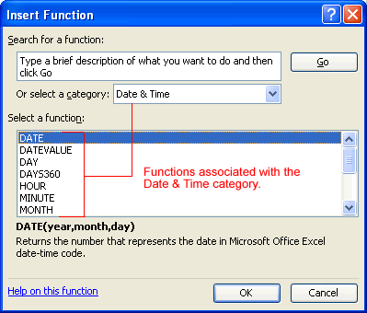

* Select the function you want to use and then click the **OK** button.

### orting, Grouping, and Filtering Cells

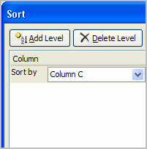A Microsoft Excel spreadsheet can contain a great deal of information. With more rows and columns than previous versions, Excel 2007 gives you the ability to **analyze** and work with an **enormous amount of data**. To most effectively use this data, you may need to manipulate this data in different ways.   
  
In this lesson, you will learn how to **sort**, **group**, and **filter** data in various ways that will enable you to most effectively and efficiently use spreadsheets to locate and analyze information.

### Sorting, Grouping, and Filtering

[Watch the video!](http://www.gcflearnfree.org/content/screencasts/shared/player_776x600.aspx?screenCast=ex07_sort) (10:13min) - [Tips](http://www.gcflearnfree.org/PopUps/VideoTips.aspx) for watching our videos.

Download the [example](http://www.gcflearnfree.org/content/downloads/ex07_Inventory_lesson10.xlsx) to work along with the video.

A Microsoft Excel spreadsheet can contain a great deal of information. Sometimes you may find that you need to reorder or sort that information, create groups, or filter information to be able to use it most effectively.

### Sorting

**Sorting lists** is a common spreadsheet task that allows you to easily reorder your data. The most common type of sorting is alphabetical ordering, which you can do in ascending or descending order.

##### To Sort in Alphabetical Order:

* Select a cell in the column you want to sort (In this example, we choose a cell in column A).
* Click the **Sort & Filter** command in the **Editing** group on the Home tab.
* Select **Sort A to Z**. Now the information in the Category column is organized in alphabetical order.

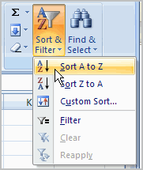

You can search in reverse alphabetical order by choosing **Sort Z to A** in the list.

##### To Sort from Smallest to Largest:

* Select a cell in the column you want to sort (a column with numbers).
* Click the **Sort & Filter** command in the **Editing** group on the Home tab.
* Select **From Smallest to Largest**. Now the information is organized from the smallest to largest amount.

You can sort in **reverse numerical order** by choosing **From Largest to Smallest** in the list.

##### To Sort Multiple Levels:

* Click the **Sort & Filter** command in the **Editing** group on the Home tab.
* Select **Custom Sort** from the list to open the dialog box.

OR

* Select the **Data** tab.
* Locate the **Sort and Filter** group.
* Click the **Sort** command to open the **Custom Sort** dialog box. From here, you can sort by one item, or multiple items.

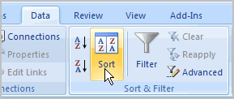

* Click the drop-down arrow in the **Column Sort by** field, and choose one of the options. In this example, Category.

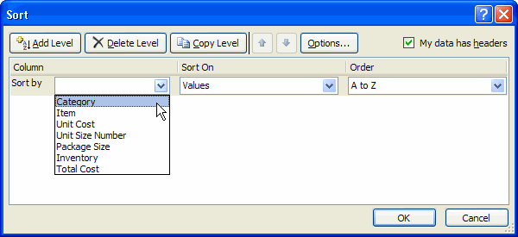

* Choose what to **sort on**. In this example, we'll leave the default as **Value**.
* Choose how to **order the results**. Leave it as **A to Z** so it is organized alphabetically.
* Click **Add Level** to add another item to sort by.

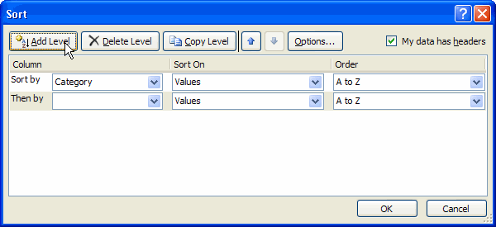

* Select an option in the **Column Then by** field. In this example, we chose Unit Cost.
* Choose what to **sort on**. In this example, we'll leave the default as **Value**.
* Choose how to **order the results**. Leave it as **smallest to largest**.
* Click **OK**.

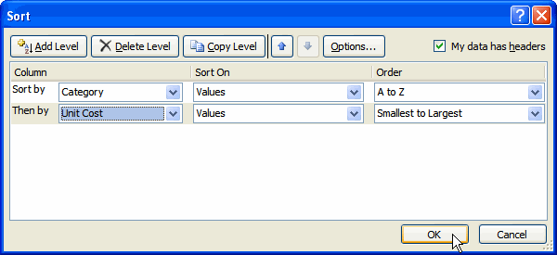

The spreadsheet has been sorted. All the categories are organized in alphabetical order, and within each category, the unit cost is arranged from smallest to largest.

Remember all of the information and data is still here. It's just in a different order.

### Grouping Cells Using the Subtotal Command

**Grouping** is a really useful Excel feature that gives you control over how the information is displayed. You must **sort before you can group**. In this section we will learn how to create groups using the Subtotal command.

##### To Create Groups with Subtotals:

* Select any cell with information in it.
* Click the **Subtotal** command. The information in your spreadsheet is automatically selected and the Subtotal dialog box appears.

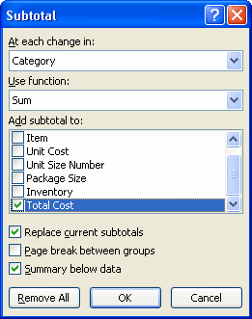

* Decide how you want things grouped. In this example, we will organize by **Category**.
* Select a **function**. In this example, we will leave the SUM function selected.
* Select the column you want the Subtotal to appear. In this example, Total Cost is selected by default.
* Click **OK**. The selected cells are organized into **groups with subtotals**.

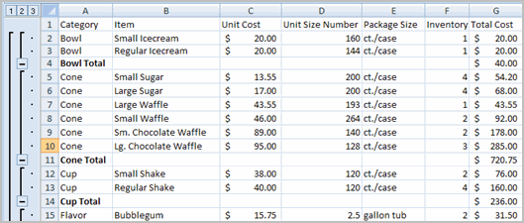

##### To Collapse or Display the Group:

* Click the **black minus** sign, which is the **hide detail** icon, to **collapse** the group.
* Click the **black plus** sign, which is the **show detail** icon, to expand the group.
* Use the **Show Details** and **Hide Details** commands in the Outline group to collapse and display the group, as well.

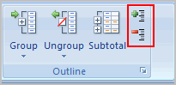

##### To Ungroup Select Cells:

* Select the cells you want to **remove** from the group.
* Click the **Ungroup** command.
* Select **Ungroup** from the list. A dialog box will appear.
* Click **OK**.

##### To Ungroup the Entire Worksheet:

* Select all the cells with grouping.
* Click **Clear Outline** from the menu.

### Filtering Cells

Filtering, or temporarily hiding, data in a spreadsheet very easy. This allows you to focus on specific spreadsheet entries.

##### To Filter Data:

* Click the **Filter** command on the **Data** tab. Drop-down arrows will appear beside each column heading.

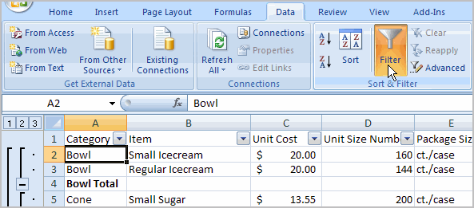

* Click the drop-down arrow next to the heading you would like to filter. For example, if you would like to only view data regarding **Flavors**, click the drop-down arrow next to **Category**.

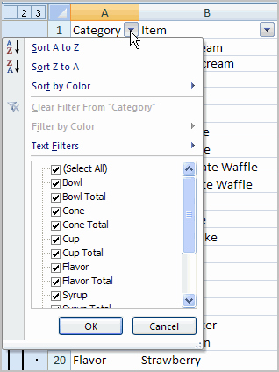

* Uncheck **Select All**.
* Choose Flavor.
* Click OK. All other data will be filtered, or hidden, and only the Flavor data is visible.

##### To Clear One Filter:

* Select one of the drop-down arrows next to a filtered column.
* Choose **Clear Filter From...**.

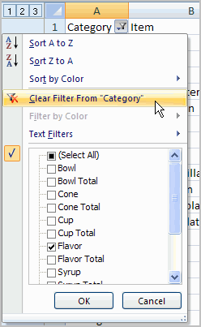

To remove all filters, click the Filter command.

Filtering may look a little like grouping, but the difference is that now I can filter on another field, if I want to. For example, let’s say I want to see only the **Vanilla-related** flavors. I can click the drop-down arrow next to Item, and select **Text Filters**. From the menu, I’ll choose **Contains** because I want to find any entry that has the word **vanilla** in it. A dialog box appears. We’ll type Vanilla, and then click OK. Now we can see that the data has been filtered again and that only the Vanilla-related flavors appear.

### Formatting Tables

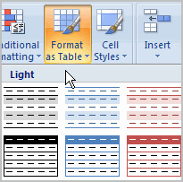Once you have entered information into a spreadsheet, you may want to **format** it. Formatting your spreadsheet can not only make it look nicer, but make it easier to use. In a previous lesson we discussed many manual formatting options such as bold and italics. In this lesson, you will learn how to use the **predefined tables styles** in Excel 2007 and some of the **Table Tools** on the Design tab.

### Formatting Tables

[Watch the video!](http://www.gcflearnfree.org/content/screencasts/shared/player_776x600.aspx?screenCast=ex07_format_tables) (3:45 min) - [Tips](http://www.gcflearnfree.org/PopUps/VideoTips.aspx) for watching our videos.

Download the [example](http://www.gcflearnfree.org/content/downloads/ex07_Inventory_lesson11.xlsx) to work along with the video.

##### To Format Information as a Table:

* Select any cell that contains information.
* Click the **Format as Table** command in the **Styles** group on the Home tab. A list of predefined tables will appear.

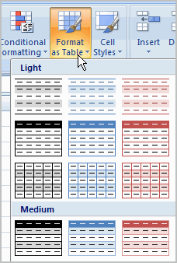

* Left-click a **table style** to select it.
* A dialog box will appear. Excel has **automatically selected the cells** for your table. The cells will appear selected in the spreadsheet and the range will appear in the dialog box.

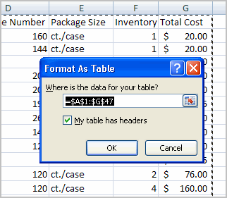

* Change the **range** listed in the field, if necessary.
* Verify the box is selected to indicate your table has **headings**, if it does. Deselect this box if your table does not have column headings.
* Click OK. The table will appear formatted in the style you chose.

By default, the table will be set up with the **drop-down arrows in the header** so that you can filter the table, if you wish.

In addition to using the **Format as Table** command, you can also select the **Insert** tab, and click the **Table** command to insert a table.

##### To Modify a Table:

* Select **any cell** in the table. The Table Tools Design tab will become active. From here you can modify the table in many ways.

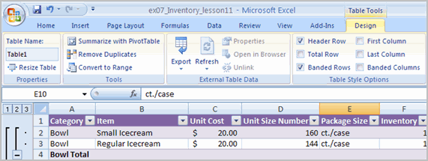

You can:

* Select a **different table** in the **Table Styles Options** group. Click the **More** drop-down arrow to see more table styles.
* Delete or add a **Header Row** in the Table Styles Options group.
* Insert a **Total Row** in the Table Styles Options group.
* Remove or add **banded rows or columns**.
* Make the first and last columns **bold**.
* **Name** your table in the Properties group.
* Change the cells that make up the table by clicking **Resize Table**.

When you apply a table style, filtering arrows automatically appear. To **turn off filtering**, select the Home tab, click the **Sort & Filter** command, and select **Filter** from the list.

### Aligning Text

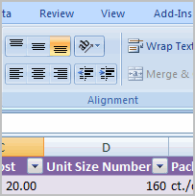Worksheets that have not been formatted are often very difficult to read. Fortunately, Excel gives you many tools that allow you to **format text** and tables in various ways. One of the ways you can format your worksheet so that it is easier to work with is to apply different types of **alignment to text**.  
  
In this lesson, you will learn how to left, center, and right align text, merge and center cells, vertically align text, and apply different types of text control.

### Formatting Cells

[Watch the video!](http://www.gcflearnfree.org/content/screencasts/shared/player_776x600.aspx?screenCast=ex07_align_text) (5:17 min) - [Tips](http://www.gcflearnfree.org/PopUps/VideoTips.aspx) for watching our videos.

Download the [example](http://www.gcflearnfree.org/content/downloads/ex07_Inventory_lesson12.xlsx) to work along with the video.

### Aligning Text

Excel 2007 **left-aligns text** (labels) and **right-aligns numbers** (values). This makes data easier to read, but you do not have to use these defaults. Text and numbers can be defined as left-aligned, right-aligned or centered in Excel.

##### To Align Text or Numbers in a Cell:

* Select a cell or range of cells
* Click on either the **Align Left, Center** or **Align Right** commands on the Home tab.

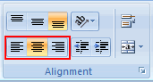

* The text or numbers in the cell(s) take on the selected alignment treatment.

Left-click a column label to select the entire column, or a row label to select an entire row.

### Changing Vertical Cell Alignment

You can also define vertical alignment in a cell. In **Vertical alignment**, information in a cell can be located at the top of the cell, middle of the cell or bottom of the cell. The default is bottom.

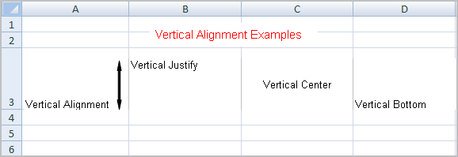

##### To Change Vertical Alignment from the Alignment Group:

* Select a cell or range of cells.
* Click the Top Align, Center, or Bottom Align command.

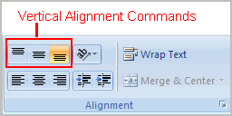

### Changing Text Control

**Text Control** allows you to control the way Excel 2007 presents information in a cell. There are two common types of Text control: **Wrapped Text and Merge Cells.**

The **Wrapped Text** wraps the contents of a cell across several lines if it's too large than the column width. It increases the height of the cell as well.

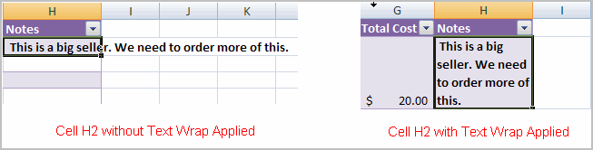

**Merge Cells** can also be applied by using the **Merge and Center** button on the Home tab.

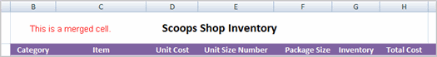

##### **To Change Text Control:**

* Select a cell or range of cells.
* Select the Home tab.
* Click the **Wrap Text** command or the **Merge and Center** command.

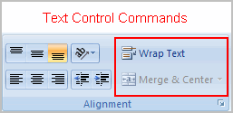

If you change your mind, click the drop-down arrow next to the command, and choose Unmerge cells.

### Working with Worksheets

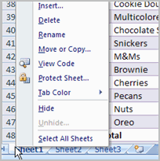It is important that you know how to **effectively manage your worksheets**. By default, three worksheets appear in each new workbook. In this lesson, you will learn how to name, add. delete, group, and ungroup worksheets. Additionally, you will learn how to freeze specific parts of the worksheet so they are always visible.

### Worksheets

[Watch the video!](http://www.gcflearnfree.org/content/screencasts/shared/player_776x600.aspx?screenCast=ex07_worksheets) (9:03 min) - [Tips](http://www.gcflearnfree.org/PopUps/VideoTips.aspx) for watching our videos.

Download the [example](http://www.gcflearnfree.org/content/downloads/ex07_Inventory_lesson13.xlsx) to work along with the video.

### Naming Worksheets

When you open an Excel workbook, there are **three sheets by default** and the default name on the tabs are Sheet1, Sheet2 and Sheet3. These are not very informative names. Excel 2007 allows you to define a meaningful name for each worksheet in a workbook so you can quickly locate information.

##### To Name a Worksheet:

* Right-click the **sheet tab** to select it.
* Choose **Rename** from the menu that appears. The text is highlighted by a black box.

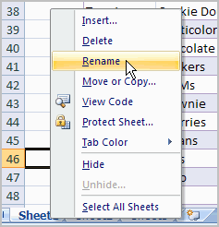

* Type a new name for the worksheet.

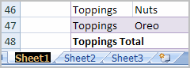

* Click off the tab. The worksheet now assumes the descriptive name defined.

OR

* Click the **Format** command in the **Cells group** on the Home tab.
* Select **Rename Sheet**. The text is highlighted by a black box.
* Type a new name for the worksheet.
* Click off the tab. The worksheet now assumes the descriptive name defined.

### Inserting Worksheets

You can change the default number of sheets that appear by clicking the **Microsoft Office Button** and choosing **Excel Options**. You also have the ability to **insert new worksheets** if needed, while you are working.

##### To Insert a New Worksheet:

* Left-click the **Insert Worksheet** icon. A new sheet will appear. It will be named Sheet4, Sheet5 or whatever the next sequential sheet number may be in the workbook.

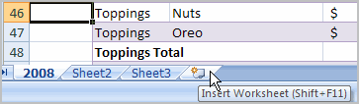

OR

* Press the **Shift** and the **F11** keys on your keyboard.

.

### Deleting Worksheets

Any worksheet can be **deleted** from a workbook, including those that have data in it. Remember, a workbook must contain at least one worksheet.

##### To Delete One or More Worksheets:

* Click on the sheet(s) you want to delete.
* Right-click the sheet(s) and a menu appears.
* Select **Delete**.

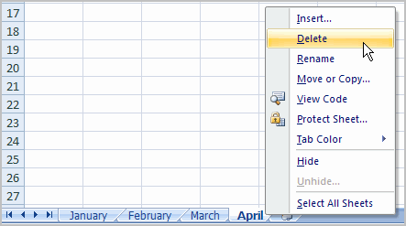

OR

* Select the sheet you want to remove.
* Click the **drop-down arrow** next to **Delete** in the Cells group on the Home tab.
* From the menu that appears, select Delete Sheet.

### Grouping and Ungrouping Worksheets

A **workbook** is a multi-page Excel document that contains multiple **worksheets**. Sometimes you will want to work with the worksheets **one at a time** as if each is a single unit. Other times, the same information or formatting may need to be added to every worksheet.

Worksheets can be combined together into a group. **Grouping** worksheets allows you to apply identical formulas and/or formatting across **all** the worksheets in the group. When you group worksheets, any changes made to one worksheet will also be changed in **any other worksheets in the group**.

##### To Group Contiguous Worksheets:

* Select the **first sheet** you want to group.
* Press and hold the **Shift key** on your keyboard.
* Click the **last sheet** you want to group.

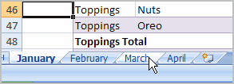

* **Release** the Shift key.
* The sheets are now **grouped**. All the sheets between the first sheet and last sheet selected are part of the group. The sheet tabs will appear white for the grouped sheets.

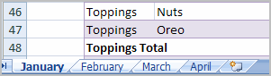

* Make any changes to one sheet and the changes will appear in all the grouped sheets.

##### To Group Non-Contiguous Sheets:

* Select the **first sheet** you want to group.
* Press and hold the **Ctrl key** on your keyboard.
* Click the **next sheet** you want to group.
* Continuing clicking the sheets you want to group.
* **Release** the Control key.
* The sheets are now grouped. The sheet tabs will appear white for the grouped sheets. Only the sheets selected are part of the group.
* Make any changes to one sheet and the changes will appear in all the grouped sheets.

##### To Ungroup Worksheets:

* Right-click one of the sheets.
* Select **Ungroup** from the list.

### Freezing Worksheet Panes

The ability to **freeze**, or **lock**, specific rows or columns in your spreadsheet is a really useful feature in Excel. It is called **freezing panes**. When you freeze panes, you select rows or columns that will remain visible all the time, even as you are scrolling. This is particularly useful when working with large spreadsheets.

##### To Freeze a Row:

* Select the row **below** the one that you want frozen. For example, if you want row 1 & 2 to appear at the top even as you scroll, then select row 3.

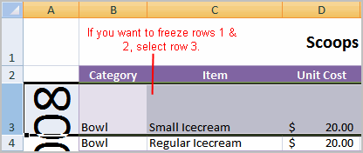

* Click the **View** tab.
* Click the **Freeze Pane** command in the Window group.

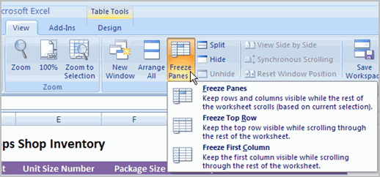

* Choose **Freeze Panes**. A thin, black line appears **below** everything that is frozen in place.

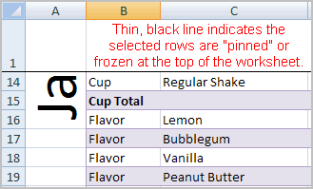

* Scroll down in the worksheet to see the pinned rows.

##### To Unfreeze a Pane:

* Click the **Freeze Pane** command.
* Select the **Unfreeze** command.

##### To Freeze a Column:

* Select the column to the **right** of the column(s) you want frozen. For example, if you want columns A & B to always appear on the left, just select column C.
* Click the **View** tab.
* Click the **Freeze Pane** command in the Window group.
* Choose **Freeze Pane**. A thin, black line appears to the **right** of the frozen area.
* Scroll across in the worksheet to see the pinned columns.

### Using Templates

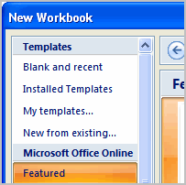In Excel 2007, you have many templates that can save you a lot of time. A **template** is a pre-designed spreadsheet that you can use to create new spreadsheets with the **same formatting** and **predefined formulas**. With templates, you don't need to know how to do the math, or even how to write formulas -- these are already integrated into the spreadsheet.   
  
In this lesson, you will learn how to create a new workbook with a template, as well as basic information about how templates work in Excel 2007.

### Templates

[Watch the video!](http://www.gcflearnfree.org/content/screencasts/shared/player_776x600.aspx?screenCast=ex07_templates) (3:30 min) - [Tips](http://www.gcflearnfree.org/PopUps/VideoTips.aspx) for watching our videos.

Excel allows you to create new workbooks using **templates**, or a **predefined pattern**. Several templates are preloaded in Excel and others are located on Microsoft Office Online.

##### To Create New Workbooks Using Templates On Your Computer:

* Open Excel.
* Click the **Microsoft Office Button**.
* Select **New**. The New Workbook Dialog Box appears.

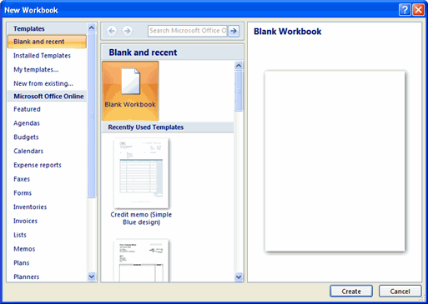

* Click **Installed Templates**. Thumbnail images of the templates that are installed on your computer appear in the center of the dialog box.

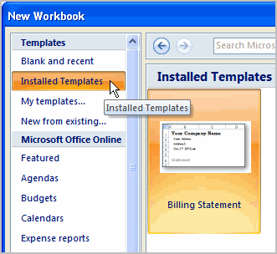

* Select a template from the center area of the dialog box. A slightly larger image of the template appears on the right side of the dialog box.
* Click **Create**. The template will appear in the Excel window.

##### To Create New Workbooks Using Templates on Office Online:

* Open Excel.
* Click **Microsoft Office Button**.
* Select **New**. The New Workbook Dialog Box appears.
* Select a **category** under the **Microsoft Office Online** heading on the left. Thumbnail images of the templates in that category that are available through Microsoft Office Online appear in the center of the dialog box.

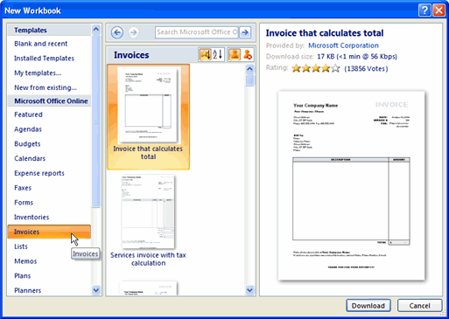

* Select a template. A slightly larger image of the template appears on the right side of the dialog box.
* Click **Download**. The download process will begin.

### Using What-if Analysis

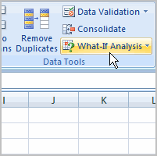The real power in Excel comes in its ability to perform multiple mathematical calculations for you. One of the tools in Excel that you can use to perform these calculations is a **Data tool** called **What-If Analysis**. What-If analysis allows you to see the effect that different values have in formulas. Have you ever thought, "What interest rate do I need to qualify for to have a car payment of $400 on the car I want?" This question can be answered using What-If Analysis.   
  
In this lesson, you will learn how to use a What-If Analysis tool called **Goal Seek**.

### What-if Analysis

[Watch the video!](http://www.gcflearnfree.org/content/screencasts/shared/player_776x600.aspx?screenCast=ex07_adv_functions) (5:18min) - [Tips](http://www.gcflearnfree.org/PopUps/VideoTips.aspx) for watching our videos.

Download the [example](http://www.gcflearnfree.org/content/downloads/ex07_carloan_lesson15.xlsx) to work along with the video.

### Example

You need a loan to buy a new car. You know how much **money** you want to borrow, how long of a period you want to take to pay off the loan **(the term)**, and what **payment** you can afford to make each month. But, what you need to know is what interest rate you to qualify for to make the payment $400 a month. In the image below, you can see that if you didn’t have interest and just divided this $20,000 into 60 monthly payments, you would pay $333.33 a month. The **What-If Analysis** tool will allow you to easily calculate the interest rate.

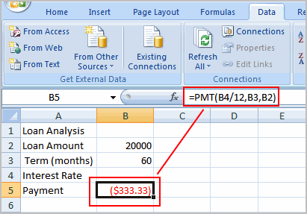

##### Where Did the Formula Come From?

The **formula** that appears in **cell B5** in the example image is a **function**. It isn't part of the What-if Analysis tool, so you will need to understand functions thoroughly before you use What-if Analysis. For the example scenario described above, you need a formula that will calculate the monthly payment. Instead of writing the formula yourself, you can insert a function to do the calculation for you.

##### To Insert a Payment Function:

* Select the **Formula** tab.
* Click the **Insert Function** command. A dialog box appears.
* Select **PMT**.
* Click **OK**. A dialog box appears.
* Insert your cursor in the **first field**. A description about the needed information appears at the bottom of the dialog box.

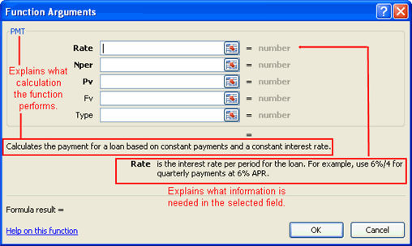

* Select the cell in the spreadsheet with the needed information.
* Insert your cursor in the **next field**. A description about the needed information appears at the bottom of the dialog box.
* Select the cell in the spreadsheet with the needed information.
* Repeat the last two steps until all the necessary information is entered in the dialog box.
* Click **OK**.

### What-If Analysis Tools

There are **three** What-If analysis tools that you can use. To access these, select the **Data** tab, and locate the **What-If Analysis command**. If you click this command, a menu with three options appears.   
  
**Goal seek** is useful if you know the needed **result**, but need to find the **input value** that will give you the desired result. In this example, we know the desired result (a $400 monthly payment), and are seeking the input value (the interest rate).

### Goal Seek

##### To Use Goal Seek to Determine an Interest Rate:

* Select the **Data** tab.
* Locate the **Data Tools** group.
* Click the **What-If Analysis** command. A list of three options appears.

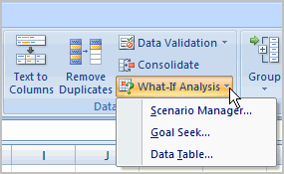

* Select **Goal Seek**. A small dialog box appears.
* Select the **cell** that you what to set to a **specific value**. In this example, we want to set B5, the Payment cell.

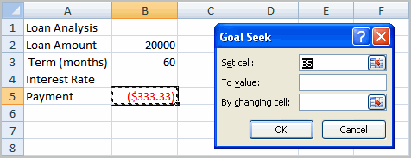

* Insert the cursor in the next field.
* Enter a **value** in the **value field**. In this example, type **-$400**. Since we’re making a payment that will be subtracted from our loan amount, we have to enter the payment as a negative number.

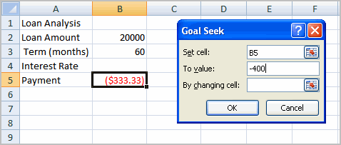

* Insert the cursor in the next field.
* Select the **cell** that you want to change. This will be the cell that tries various **input values**. In this example, select cell B4, which is the interest rate.

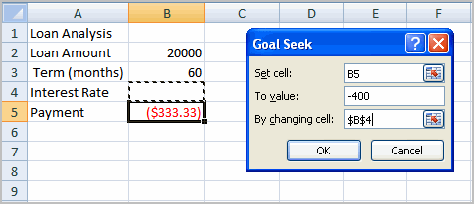

* Click **OK**.
* Then, click **OK** again. The interest rate appears in the cell. This indicates that a 7% interest rate will give us a $400 a month payment on a $20,000 loan that is paid off over 5 years, or 60 months.

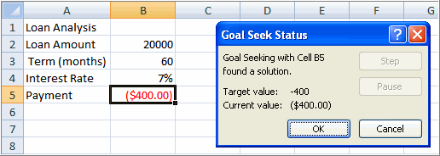

### Working with Charts

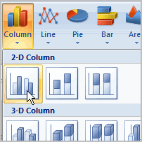A **chart** is a tool you can use in Excel to communicate your **data graphically**. Charts allow your audience to more easily see the meaning behind the numbers in the spreadsheet, and make showing comparisons and trends a lot easier. In this lesson, you will learn how to **insert** and **modify** Excel charts and see how they can be an effective tool for communicating information.

### Charts

[Watch the video!](http://www.gcflearnfree.org/content/screencasts/shared/player_776x600.aspx?screenCast=ex07_charts) (9:25 min) - [Tips](http://www.gcflearnfree.org/PopUps/VideoTips.aspx) for watching our videos.

Download the [example](http://www.gcflearnfree.org/content/downloads/ex07_companysales_lesson16.xlsx) to work along with the video.

### Creating a Chart

Charts can be a useful way to communicate data. When you insert a chart in Excel, it appears in the selected worksheet with the source data, by default.

##### To Create a Chart:

* Select the **worksheet** you want to work with. In this example, we use the **Summary** worksheet.
* Select the **cells** that you want to chart, including the **column titles** and the **row labels**.
* Click the **Insert** tab.
* Hover over each **Chart option** in the Charts group to learn more about it.
* Select one of the Chart options. In this example, we use the Columns command.
* Select a **type of chart** from the list that appears. For this example, we use a 2-D Clustered Column. The chart appears in the worksheet.

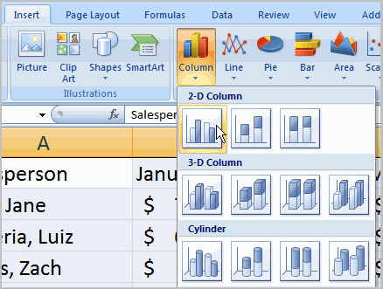

### Identifying the Parts of a Chart

Have you ever read something you didn't fully understand but when you saw a chart or graph, the concept became clear and understandable? Charts are a **visual representation** of data in a worksheet. Charts make it easy to see comparisons, patterns, and trends in the data.

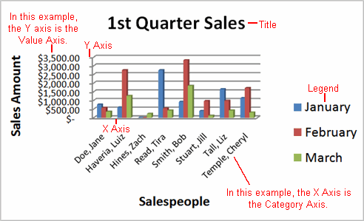

##### Source Data

The range of cells that make up a chart. The chart is updated automatically whenever the information in these cells change.

##### Title

The title of the chart.

##### Legend

The chart key, which identifies each color on the chart represents.

##### Axis

The vertical and horizontal parts of a chart. The vertical axis is often referred to as the Y axis, and the horizontal axis is referred to as the X axis.

##### Data Series

The actual charted values, usually rows or columns of the source data.

##### Value Axis

The axis that represents the values or units of the source data.

##### Category Axis

The axis identifying each data series.

### Chart Tools

Once you insert a chart, a new set of **Chart Tools**, arranged into 3 tabs, will appear above the Ribbon. These are only visible when the chart is selected.

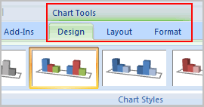

##### To Change the Chart Type:

* Select the **Design** tab.
* Click the **Change Chart Type** command. A dialog box appears.

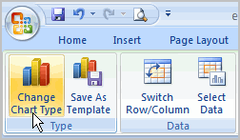

* Select another **chart type**.
* Click OK.

The chart in the example compares each salesperson's monthly sales to his/her other month's sales; however you can change what is being compared. Just click the **Switch Row/Column Data** command, which will rotate the data displayed on the **x** and **y axes**. To return to the **original view**, click the Switch Row/Column command again.

##### To Change Chart Layout:

* Select the **Design** tab.
* Locate the **Chart Layouts** group.
* Click the **More** arrow to view all your layout options.

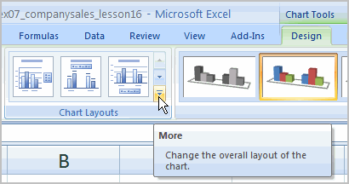

* Left-click a layout to select it.

If your new layout includes chart titles, axes, or legend labels, just insert your cursor into the text and begin typing to add your own text.

##### To Change Chart Style:

* Select the **Design** tab.
* Locate the **Chart Style** group.
* Click the **More** arrow to view all your style options.
* Left-click a style to select it.

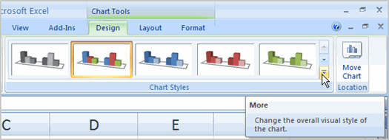

##### To Move the Chart to a Different Worksheet:

* Select the **Design** tab.
* Click the **Move Chart** command. A dialog box appears. The current location of the chart is selected.
* Select the desired location for the chart (i.e., choose an existing worksheet, or select New Sheet and name it).

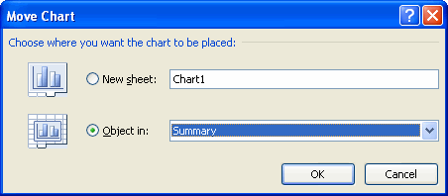

### Using Conditional Formatting

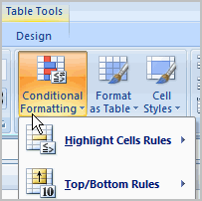Imagine you have a spreadsheet with thousands of rows of data. It would be extremely difficult to see patterns and trends just from examining the raw data. Excel gives us several tools that will make this task easier. One of these tools is called **conditional formatting**. With conditional formatting, you can apply formatting to **one or more cells** based on the value of the cell. You can highlight interesting or unusual cell values, and visualize the data using formatting such as data bars.  
  
In this lesson, you will learn how to apply, modify, and delete conditional formatting rules.

### Conditional Formatting

[Watch the video!](http://www.gcflearnfree.org/content/screencasts/shared/player_776x600.aspx?screenCast=ex07_cond_format) (5:17 min) - [Tips](http://www.gcflearnfree.org/PopUps/VideoTips.aspx) for watching our videos.

Download the [example](http://www.gcflearnfree.org/content/downloads/ex07_companysales_lesson17.xlsx) to work along with the video.

##### The Conditional Formatting Options

You have many **conditional formatting** rules, or options, that you can apply to cells in your spreadsheet. Each **rule** will affect selected cells differently. Before you choose a formatting rule, you need to identify what questions you are trying to answer. For example, in a sales spreadsheet, you might want to identify the salespeople with lower than average sales. To do this, you need to choose a conditional formatting rule that will show you this answer. Not all of the options will provide you with this information.

**Some of the Conditional Formatting Options Include:**

* **Highlight Cell Rules:** This rule highlights **specific cells** based on your option choice. For example, you can choose for Excel to highlight cells that are greater than, less than, or equal to a number, and between two numbers. Also, you can choose for Excel to highlight cells that contain specific text, including a specific date. If you choose this option, a **dialog box** will appear, and you will have to specify the cells to highlight, and the color you would like to highlight the cells.

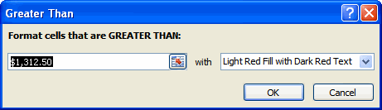

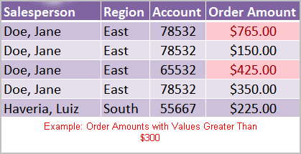

* **Top/Bottom Rules:** This conditional formatting option highlights cell values that meet specific criteria, such as top or bottom 10%, above average, and below average. If you choose this option, a **dialog box** will appear, and you will have to specify the cells to highlight, and the color you would like to highlight the cells.

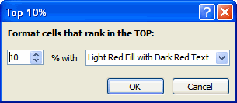

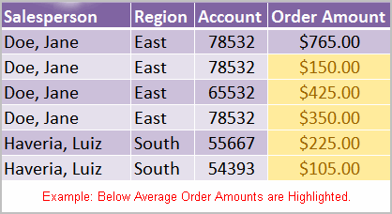

* **Data Bars:** This is an interesting option that formats the selected cells with colored bars. The length of the data bar represents the value in the cell. The longer the bar, the higher the value.

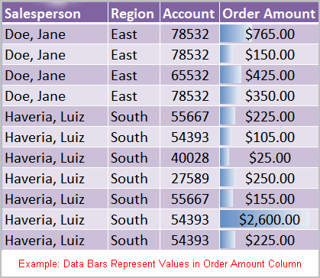

* **Color Scales:** This option applies a two or three color gradient to the cells. Different shades and colors represent specific values.

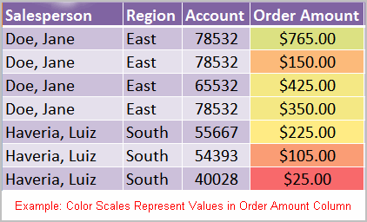

##### To Apply Conditional Formatting:

* Select the cells you would like to format.
* Select the **Home** tab.
* Locate the **Styles** group.
* Click the **Conditional Formatting** command. A menu will appear with your formatting options.

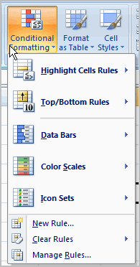

* Select **one of the options** to apply it to the selected cells. A cascading menu will appear.

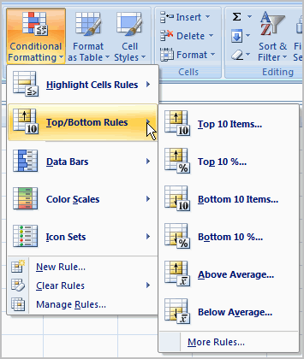

* An additional dialog box may appear, depending on the option you choose.
* If so, make the necessary choices, and click OK.

##### To Remove Conditional Formatting Rules:

* Click the **Conditional Formatting** command.
* Select **Clear Rules**. A cascading menu appears.
* Choose to clear rules from the **entire worksheet** or the **selected cells**.

##### To Manage Conditional Formatting Rules:

* Click the **Conditional Formatting** command.
* Select **Manage Rules** from the menu. The Conditional Formatting Rules Manager dialog box will appear.

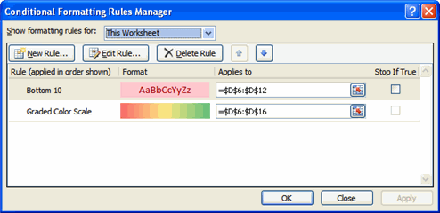

* From here you can edit a rule, delete a rule, or change the order of rules.

### Creating Pivot Tables

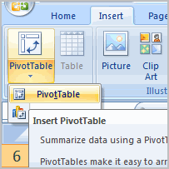Pivot table reports, or **pivot tables** as they are often called, can help you answer questions about your spreadsheet by analyzing the numerical information in various ways. If you work with spreadsheets with a lot of data, pivot tables can be an extremely useful tool. Pivot table reports give you power because you can **quickly find the answer** to many different questions, and manipulate your data in many different ways.  
  
In this lesson, you will learn the basics of inserting and working with pivot table reports.

### Pivot Table Reports

[Watch the video!](http://www.gcflearnfree.org/content/screencasts/shared/player_776x600.aspx?screenCast=ex07_pivot) (10:41 min) - [Tips](http://www.gcflearnfree.org/PopUps/VideoTips.aspx) for watching our videos.

Download the [example](http://www.gcflearnfree.org/content/downloads/ex07_companysales_lesson18.xlsx) to work along with the video.

##### Why are They Named Pivot Tables?

You may be wondering why it is called a pivot table. Basically, pivot tables allow you to **pivot**, or **move**, data so that you can produce answers to questions. Once you create a pivot table, you can very easily see what effect pivoting the data has on the spreadsheet information.

##### To Create a Pivot Table Report (Part I):

* Select the cells in your spreadsheet that you want to use in the pivot table report.
* Select the **Insert** tab.
* Click the **PivotTable** command.
* Click **PivotTable** again. Excel selects cells in the actual spreadsheet and the **Create PivotTable** dialog box opens.
  + **Select a table or range** is already selected and the **Table/Range** field shows the range of the selected data. **New Worksheet** is also selected by default as the place where the report will be placed.

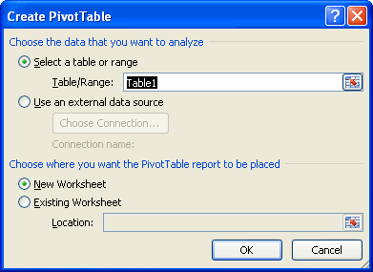

* Click **Existing Worksheet** and select a worksheet, if you do not want the pivot table to appear in a new worksheet.
* Click **OK**.

##### Creating a Pivot Table Report

If you use the sample spreadsheet to create a pivot table, you can see that the column headings are **salesperson**, **region**, **account**, **order amount**, and **month**. When you create a pivot table, each **column label** in your data becomes **a field** that can be used in the report. The **Field List** appears on the right side of the report, while the **layout area** appears on the left.

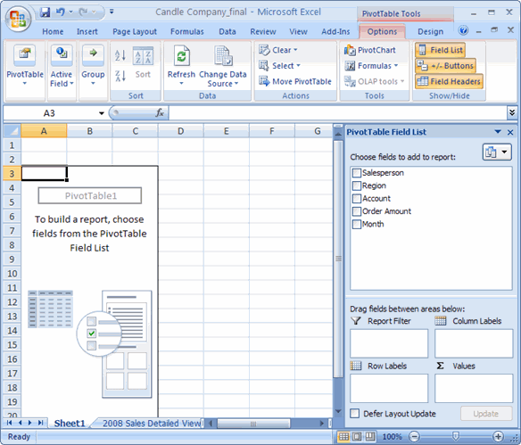

##### To Create a Pivot Table Report (Part 2):

* Determine what **question** you want your pivot table report to answer. For example, using the sample spreadsheet, you might want to know **which salesperson sold the greatest dollar amount**.
* Determine the **fields** that are necessary to answer this question. In this example, **salesperson** and **order amount**.
* Select the check box next to the **Salesperson field** in the **PivotTable Field List**. The field will appear in the drag and drop area at the bottom of the field list and in the layout area. The order amount data appears on the right. This is a default setting in Excel – data with numbers will always appear on the right.
* Select the check box next to the **Order Amount field** in the **PivotTable Field List**. The field will appear in the drag and drop area at the bottom of the field list and in the layout area. All of the salesperson data appears on the left side as rows.
* You can now see the **answer to your question** in the **report** on the left.

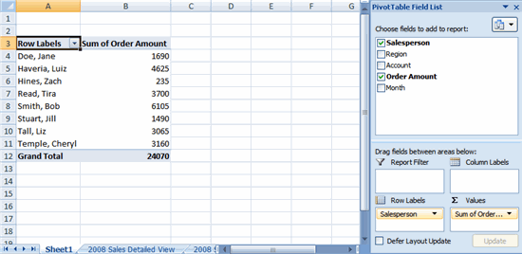

##### To Add a Report Filter:

* Select a **field** in the **Field List**. In this example, choose **Region**. By default, it will appear in the Row Labels group.
* Click and drag **Region** into the **Report Filter** section.
* Release the mouse button. The region appears at the top of the report as a filter.
* The **arrow** by the Region fields shows (All). To show just the data for a **specific region**, click the drop-down arrow and select the region. To see **multiple regions**, click the Multiple Regions box, select the regions to display, and then, click OK.

##### Moving, or Pivoting Data:

* Click and drag a **field** from one area to another.

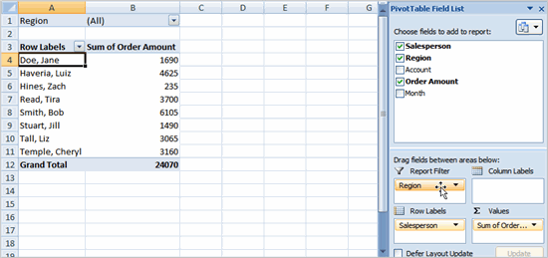

* Release the mouse button to drop the field in the new area. In this example, we move **Region** from **Report Filter** to **Column Label**. The pivot table report will change.

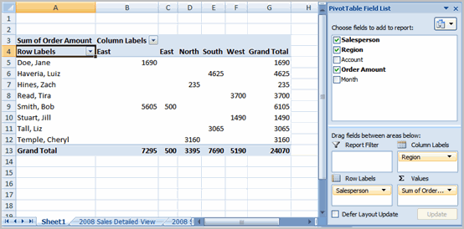

OR

* Right-click one of the rows. A menu will appear.
* Select **Move** and then select a move option.

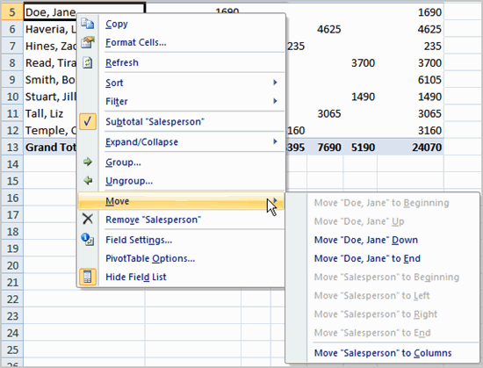

##### To Create a PivotChart

* Select the **Pivot Chart** command from the Options tab. The Insert Chart dialog box appears.

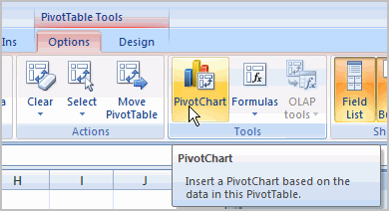

* Select the chart you’d like to insert.
* Click OK. The chart will now appear on the same sheet as the Pivot Table.

The information in the chart includes the information in the pivot table, rather than all the original source data.